Investigation of Antimicrobial and Antioxidant Properties of Extracts of the Stem Bark of Drypetes floribunda (Euphorbiaceae)

Supporting Information File

Alex Boateng¹, Joseph K. Adu^{1*}, Michael K. Baah²
¹Department of Pharmaceutical Chemistry, Faculty of Pharmacy and Pharmaceutical Sciences, College of Health Sciences, Kwame Nkrumah University of Science and Technology (KNUST), Kumasi, Ghana.
²Department of Pharmacognosy, Faculty of Pharmacy and Pharmaceutical Sciences, College of Health Sciences, Kwame Nkrumah University of Science and Technology (KNUST), Kumasi, Ghana.

*Corresponding Author:
Dr Joseph K. Adu
Department of Pharmaceutical Chemistry, Faculty of Pharmacy and Pharmaceutical Sciences, College of Health Sciences, KNUST, Kumasi.
Tel: (+233) (0)508265823
Email: jkadu2000@yahoo.com, jadu.pharm@knust.edu.gh

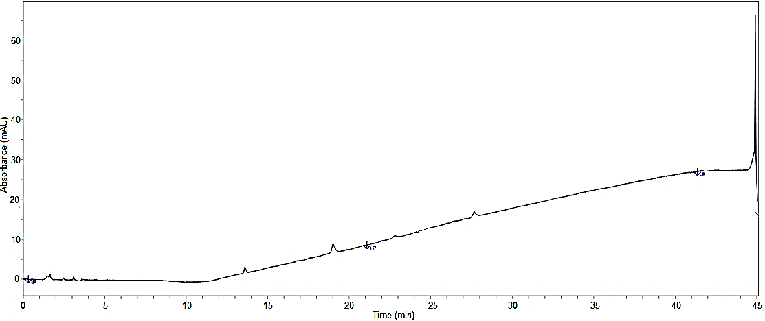
Retention Time (minutes)

Figure 6. HPLC chromatogram of the blank

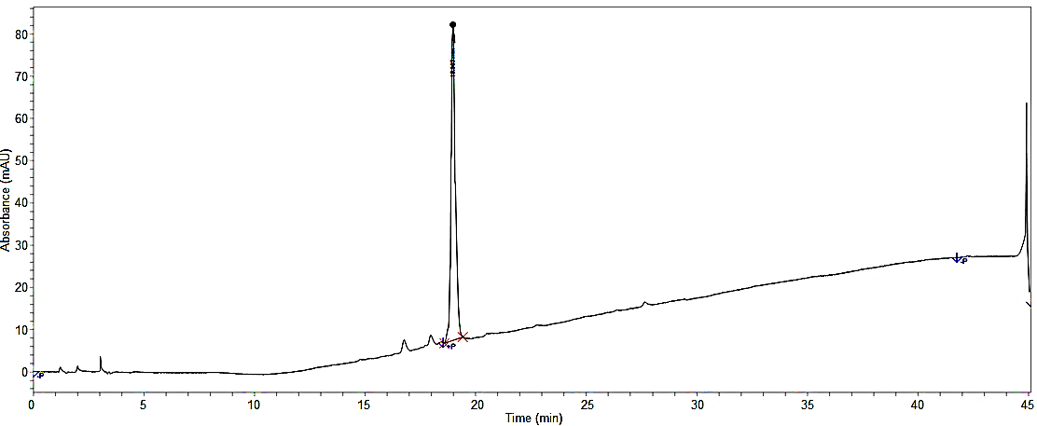
Retention Time (minutes)
Figure 7. HPLC chromatogram of compound F₁₄
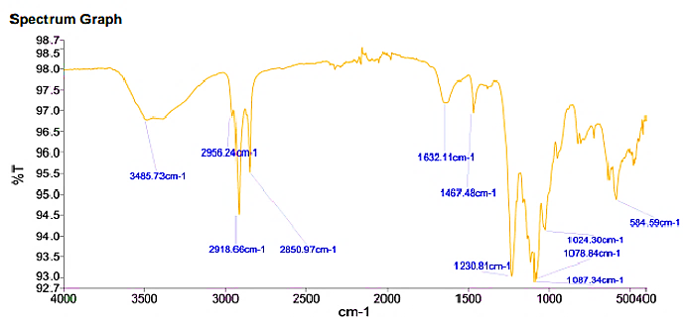
Figure 8. IR spectrum of compound F₅

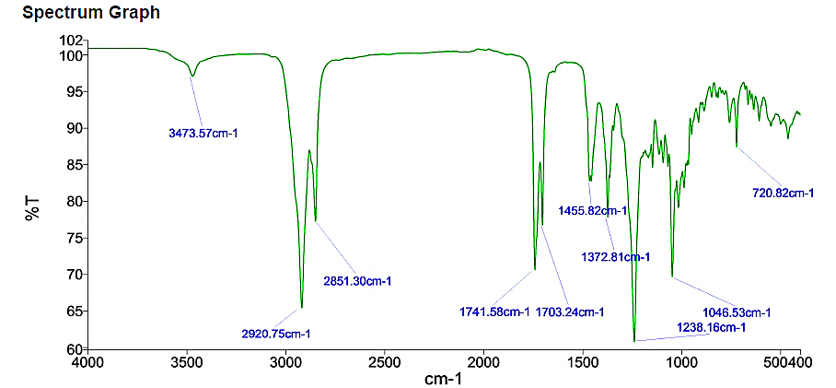

Figure 9: IR spectrum of compound F₁₀

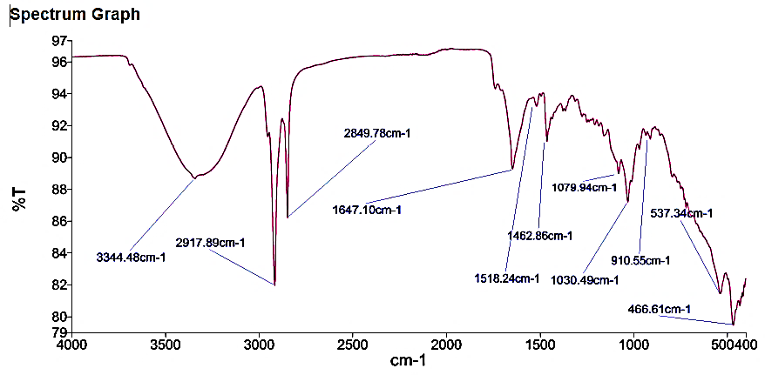
Figure 10. IR spectrum of compound F₁₄

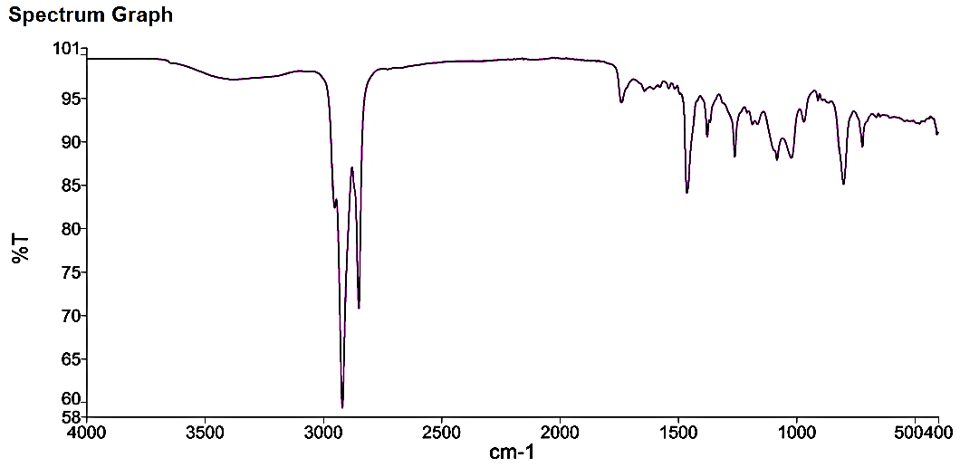

Figure 11. IR spectrum of compound F₂₂

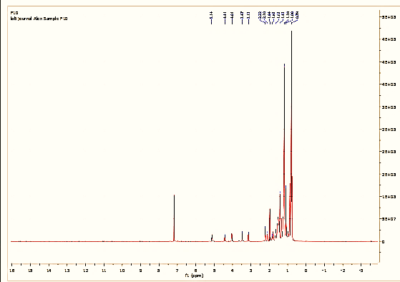

Figure 12. 1D PMR spectrum of F₁₀

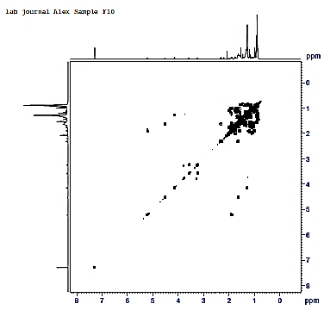

Figure 13. COSY 2D PMR spectrum of F₁₀

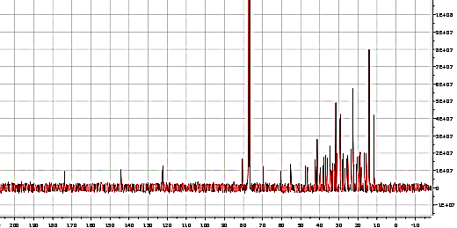
Figure 14. C-13 NMR spectrum of F₁₀

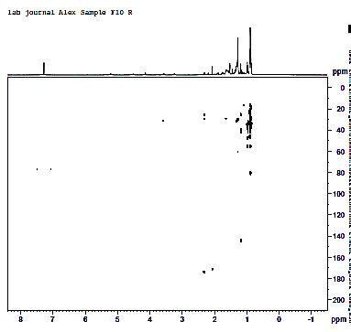
Figure 15. HMBC 2D NMR spectrum of F₁₀
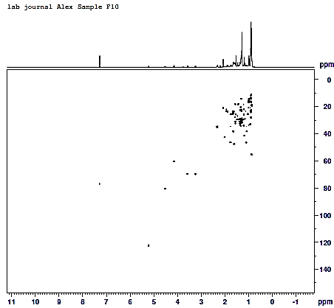
Figure 16. HSQC 2D NMR spectrum of F₁₀

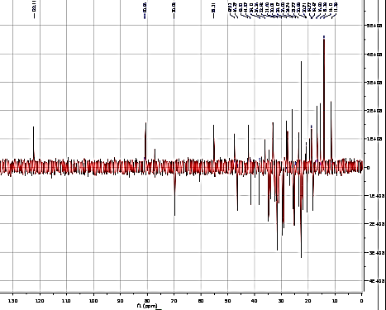
Figure 17. DEPT 135 NMR spectrum of F₁₀

