Antibacterial potential and mechanism of action of botanicals and phytochemicals from Stachytarpheta cayennensis (Verbenaceae) against Gram-negative multidrug-resistant phenotypes expressing efflux pumps

Laetitia M. Youmbi^{1,3}, Brice C.K. Atontsa², Simplice B. Tankeo¹, Elvis B. Wamba¹, Paul Nayim¹, Blaise K. Nganou², Gabin T.M. Bitchagno², Ingrid K. Simo², James D.S. Mpetga², Veronique B. Penlap³ and Victor Kuete³

¹Department of Chemistry, University of Dschang, P.O. Box 67, Dschang,Cameroon
²Department of Chemistry, University of Dschang, P.O. Box 67, Dschang, Cameroon
³Department of Biochemistry, University of Yaounde 1, Cameroun P.O. Box 812, Yaounde, Cameroon

*Corresponding authors:
Tel: (237)677355927; P.O. Box 67 Dschang, Cameroon; E-mail: kuetevictor@yahoo.fr (Prof. Victor Kuete)
Supplementary files

SF 1. Tables showing the fractionation and purification of Stachytarpheta cayennensis
Table S1. Fractionation of S. cayennensis crude extract (SC)

Solvent systems | Fractions | Fractions grouping
n-hexane-EtOAc
100 : 00 | 1 - 7 | 1 - 15 (SCa)
90 : 10 | 8 - 15 | 1 - 15 (SCa)
80 : 20 | 16 - 25 | 16 - 43 (SCb)
70 : 30 | 26 - 35 | 44 - 75 (SCc)
60 : 40 | 36 - 45 | 44 - 75 (SCc)
50 : 50 | 46 - 59 | 44 - 75 (SCc)
00 : 100 | 60 - 79 | 76 – 95 (SCd)
MeOH |  | 76 – 95 (SCd)
100 : 00 | 80 - 95 | 76 – 95 (SCd)

Table S2. Purification of fraction CSc

Solvent systems | Remarks and isolated products
n-hexane-EtOAc
100 : 00 | Complex mixture
95 : 05 | Complex mixture
90 : 10 | mixture of β-sitosterol and stigmasterol (1 and 2, 21 mg )
85 : 15 | ursolic (4, 10 mg) and oleanolic acids (5, 15 mg)
80 : 20
75 : 25
70 : 30
75 : 35
60 : 40
00 : 100 | β-sitosterol 3-O-β-D-glucopyranoside (3, 16.5 mg)
MeOH
100 : 00 | Complex mixture

SF 2. ¹H, ¹³C NMR and major chemical shifts of studied compounds

- Compounds 1 (β-sitosterol) and 2 (stigmasterol)
Mixture of β-sitostérol (1), C₂₉H₅₀O; (m/z 414) and stigmasterol (2), C₂₉H₄₈O, (m/z 412). White powder. Compound 1: ¹³C NMR (CDCl₃, 150 MHz): δ_{C} (ppm) 12.2, 12.5, 19.1, 19.5, 20.1, 21.5, 24.4, 29.4, 29.7, 31.7, 31.9, 36.5, 37.2, 39.7, 40.6, 42.2, 42.3, 50.2, 51.2, 55.9, 56.8, 71.8, 121.7 and 140.9. Compound 2: ¹³C NMR (CDCl₃, 150 MHz): δ_{C} (ppm) 12.2, 12.5, 19.1, 19.5, 20.1, 21.5, 22.7, 24.4, 25.4, 29.4, 29.7, 31.7, 31.9, 36.5, 37.2, 39.7, 40.6, 42.2, 42.3, 50.2, 51.2, 55.9, 56.8, 71.8, 121.7, 129.3, 138.5 and 140.9 [9].

FIGURE I. ¹³C NMR (CDCl₃, 150 MHz) of compounds 1 and 2

FIGURE II. ¹H NMR (CDCl₃, 600 MHz) of compounds 1 and 2
- Compound 3 (β-sitosterol 3-O-β-D-glucopyranoside)
β-sitosterol 3-O-β-D-glucopyranoside, C₃₅H₆₀O₆; (m/z 576). White powder.¹³C NMR (CDCl₃): δ_{C} (ppm) 11.7, 11.9, 18.8, 19.0, 19.2, 19.8, 21.1, 23.2, 24.3, 26.1, 28.3, 29.2, 30.0, 31.8, 31.9, 34.0, 36.2, 36.7, 37.2, 39.1, 39.7, 42.2, 45.8, 50.1, 56.0, 56.6, 62.6, 71.4, 75.1, 77.8, 78.4, 102.4, 121.7, 140.7. ¹H NMR (CDCl₃): δ_{H} (ppm) 5.25 (1H, d, J = 4.6 Hz), 4.97 (1H, d, J = 7.7 Hz), 4.48 (1H, dd, J = 2.1, 11.7 Hz), 4.33 (1H, dd, J = 5.2, 11.7 Hz), 4.23 (1H, m), 4.21 (1H, m), 3.97 (1H, pseudo-t, J = 8.2 Hz), 3.90 (1H, m), 3.85 (1H, m), 0.88 (3H, d, J = 6.4 Hz), 0.83 (3H, s), 0.80 (3H, t, J = 7.6 Hz), 0.77 (3H, d, J = 7.8 Hz), 0.76 (3H, d, J = 6.89 Hz), 0.55 (3H, s).

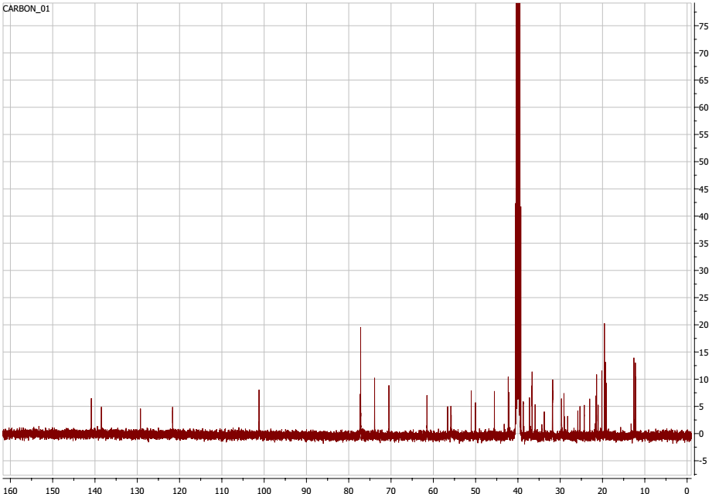

FIGURE III. ¹³C NMR (DMSO, 100 MHz) of compound 3

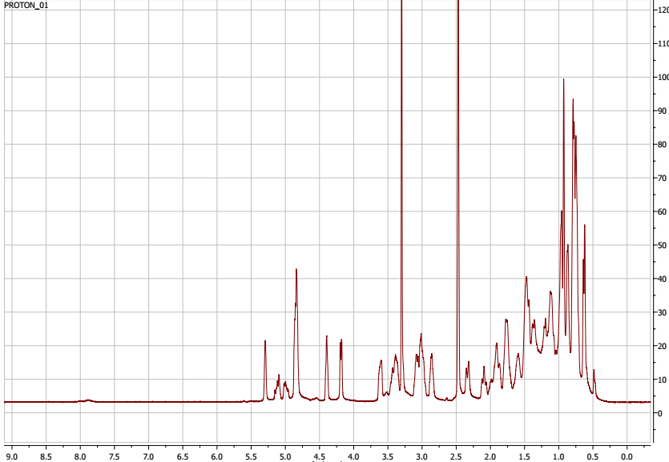
FIGURE IV. ¹H NMR (DMSO, 400 MHz) of compound 3

- Compound 4 (ursolic acid )

White powder ¹³C NMR (C₅D₅N, 125 MHz): δ_{C} (ppm) 38.9, 27.9, 78.8, 39.2, 55.7, 18.6, 33.4, 39.7, 47.6, 37.1, 23.2, 125.3, 139.1, 42.0, 28.5, 27.7, 47.6, 53.4, 39.3, 39.2,30.9,37.0, 28.6 ; 15.4,16.4, 17.3, 23.7, 179.6,17.3, 21.2. ¹H NMR (C₅D₅N, 500 MHz): δ_{H} (ppm) 1.48 (2H, m), 2.06 (2H, m), 3.41 (1H, dd, J = 11.0 and 6,0 Hz), 0.79 (1H, m), 1.48 (2H, m) 1.40 (2H, m), 1.57 (1H, m), 0.88 (2H, m), 5.40 (1H, sl), 1.77 (2H, m),1.92 (2H, m), 2.60 (1H, d, J = 12.0 Hz),1.49 (1H, m), 0.89 (1H, m), 2.26 (2H, m), 1.17 (2H, m), 1.19 (3H, s), 0.80 (3H, s), 0.98 (3H, s), 0.99 (3H, s), 1.18 (3H, s), 0.96 (3H, d, J = 6.0 Hz), 0.88 (3H, d, J = 7.1 Hz).

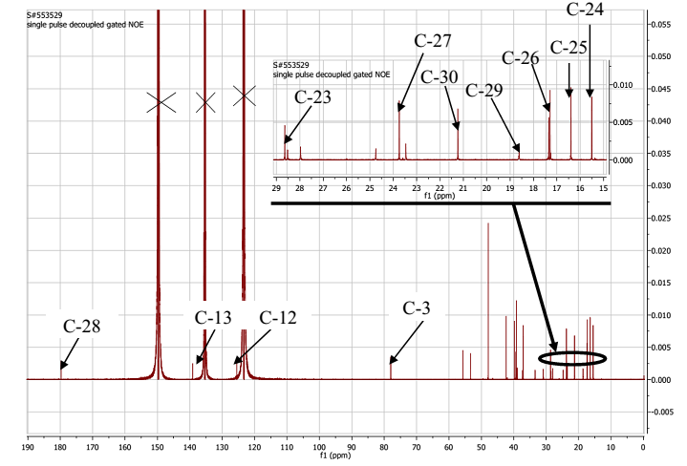
FIGURE V. Full ¹³C NMR spectrum (C₅D₅N, 125 MHz) of ursolic acid (4)

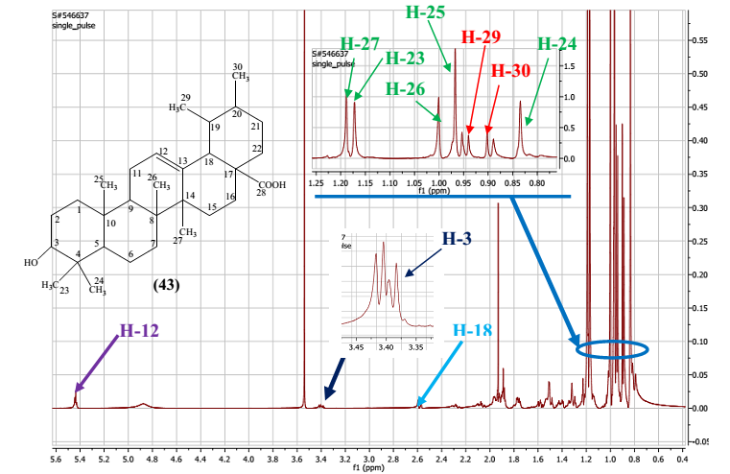
FIGURE VI. Full ¹H NMR spectrum (C₅D₅N, 500 MHz) of ursolic acid (4)

- Compound 5 (oleanoic acid)
White powder ¹³C NMR (DMSO-d₆, 100 MHz): δ_{C} (ppm) 38.0, 26.9, 76.9, 38.3, 54.8, 17.9, 32.3, 38.8, 47.0, 36.5, 22.5, 121.4, 143.7, 41.2, 27.1, 22.8, 45.6, 40.7, 45.4, 30.3, 33.3, 32.0, 28.1, 15.0, 15.8,16.7, 25.5, 178.5, 32.9, 23.3. ¹H NMR (DMSO-d₆, 400 MHz): δ_{H} (ppm) 1.43 (1H, m), 0.88 (1H, m), 0.98 (1H, m), 1.37 (1H, m), 2.87 (1H, m), 0.64 (1H, m), 1.87 (1H, m), 1.66 (1H, m), 1.57 (2H, m), 1.90 (1H, m), 2.31 (2H, m), 5.14 (1H, sl), 2.41 (2H, m), 1.85 (2H, m), 2.74 (1H, dd ; J = 13.6 and 4.0 Hz), 1.07 (1H, m), 1.55 (1H, m), 1.63 (1H, m), 1.56 (1H, m), 2.17 (1H, m), 1.80 (1H, m), 1.25 (3H, s), 1.07 (3H, s), 0.65 (3H, s), 0.84 (3H, s), 1.46 (3H, s), 0.87 (3H, s), 0.70 (3H, s).

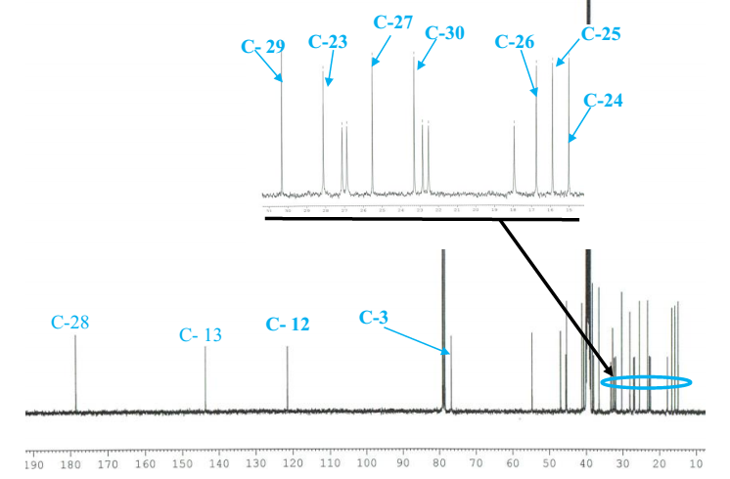
FIGURE VII. Full ¹³C NMR spectrum (DMSO-d₆, 100 MHz) of oleanoic acid (5)

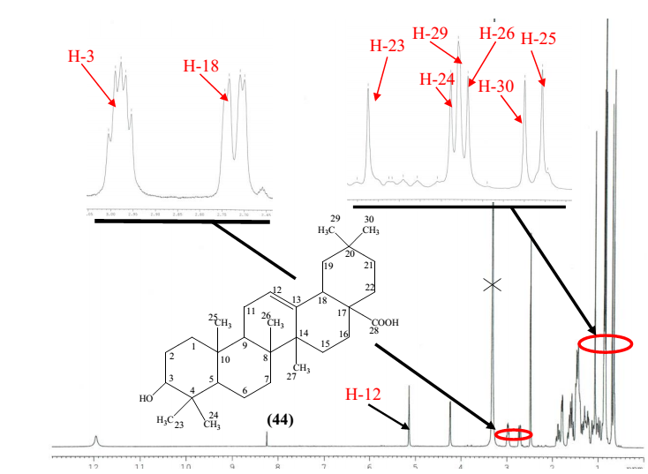
FIGURE VIII. Full ¹H NMR spectrum (DMSO-d₆, 400 MHz) of oleanoic acid (5)

